**Peshawar:**

Peshawar Museum

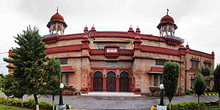

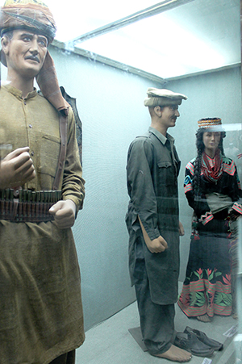

The **Peshawar Museum** is a museum located in Peshawar, capital of Pakistan’s Khyber Pakhtunkhwa province. The Peshawar Museum is notable for its collection of Buddhist artwork dating from the ancient Gandhara Empire. The Peshawar Museum was founded in 1907 as "Victoria Hall," in memory of Queen Victoria. The two-story building was built in a syncretic architectural style consisting of British, Hindu, Buddhist and Mughal Islamic styles. The museum initially had only one exhibition hall, but two more were added in 1969–70. In 2004–05, the museum was further expanded with the construction of a new block with two galleries, two halls for the museum's collection in storage, offices for the provincial directorate of archaeology, a conservation laboratory and a cafeteria. The historic exhibition hall was also renovated at that time.